A DATABASE SYSTEMS COURSE PROJECT
SKILL STREET

PROJECT REPORT

SUBMITTED BY
SAMIA FAHIM
24K-2573
BDS 4A

DATED
APRIL 2026

INTRODUCTION
Skill Street is a skill sharing platform deployed as a web application that connects neighbors who want to teach practical skills with those who want to learn them through bookable micro-sessions.
It solves the problem of untapped community knowledge by creating a trusted, location aware platform where everyday expertise such as cooking, coding, language or carpentry is accessible within your own neighborhood.
The system has three user roles:
- A Learner who browses and books sessions
- A Teacher who creates and manages sessions
- An Administrator who moderates the platform.
A single registered account can hold both the Learner and Teacher roles simultaneously.
The platform is built using HTML, CSS, JavaScript, and Bootstrap for the frontend
PHP for the backend, and PostgreSQL as the relational database.

CONTENTS
- DESIGNING
  - SYSTEM FUNCTIONALITY
  - USERS OF THE SYSTEM
  - TECHNOLOGIES USED
  - SCOPE OF THE SYSTEM
  - SCHEMA
  - NORMALIZATION
  - ENTITY RELATIONSHIP DIAGRAM
- IMPLEMENTATION
  - DATABASE CREATION
  - QUERIES
- FRONT END
- CONCLUSION

1.1 SYSTEM FUNCTIONALITY
Skill Street performs the following functions:
User Management: Registration, login, logout, and profile management across three roles — Learner, Teacher, and Admin. Passwords are stored as hashed values. User status can be set to active or suspended by the Admin.
Skill and Session Management: Teachers create sessions tied to a specific skill, setting the title, description, format (in-person or online), price, duration, address, and schedule. Learners browse and filter sessions by skill category and neighborhood.
Booking Management: Learners book sessions through a full booking lifecycle — pending, confirmed, cancelled, and completed. Teachers accept or decline incoming booking requests.
Reviews and Ratings: After a booking is marked completed, the learner can submit a star rating and comment. The teacher's average rating on their profile is automatically recalculated after every new review.
Messaging: In-app messaging between a learner and teacher is unlocked once a booking is confirmed. All messages are scoped to a specific booking.
Community Feed: Any user can post neighborhood-scoped content categorized as an announcement, help request, or skill-swap proposal. Other users can upvote posts.
Admin Panel: The administrator can view all registered users, suspend accounts, and delete community posts that violate platform rules.
1.2 USERS OF THE SYSTEM
Learner: A learner registers on the platform, sets up their profile with their neighborhood, and browses available sessions by skill or location. They can book a session, cancel a booking, message the teacher once confirmed, leave a review after completion, and post to the community feed.
Teacher: A teacher lists the skills they can teach, creates sessions with full scheduling and pricing details, and manages incoming booking requests by accepting or declining them. They can message learners, view reviews on their profile, and post to the community feed. A single user account can be both a learner and a teacher simultaneously.
Administrator: The administrator oversees the platform by viewing all registered users, suspending accounts that violate platform rules, and moderating community posts. The admin does not create sessions or make bookings.

1.3 TECHNOLOGIES USED
Frontend
- HTML
- CSS
- JavaScript
- Bootstrap
Backend
- PHP
Database
- PostgreSQL
Local Server
- XAMPP
Database GUI
- PgAdmin
Code Editor
- VS Code

1.4 SCOPE OF THE SYSTEM
In Scope: Skill Street covers user registration and authentication across three roles (learner, teacher, admin), skill and session management, booking lifecycle, reviews and ratings, in-app messaging, a neighborhood community feed, and a basic admin moderation panel, all implemented as a web application using PHP, PostgreSQL, HTML, CSS, and JavaScript.
Out of Scope: The system will not cover native mobile applications, real-time video session hosting, live payment processing, AI powered recommendations, or third party OAuth login such as Google or Facebook.
Assumptions: It is assumed that each user belongs to one neighborhood and that a single account can hold both the learner and teacher roles simultaneously. It is also assumed that all skills listed in the system are pre-seeded into the SKILL table and that reviews can only be submitted once a booking is marked as completed.

1.5 SCHEMA
USER
user_id | full_name | email | password_hash | role | bio | neighborhood | Avg_rating | status

SKILL
Skill_id | category | title | Description

SESSION
Session_id | Host_user_id | Skill_id | title | description | format | price | Max_learners | Duration_min | price | address | Scheduled_at | status | Created_at

BOOKING
Booking_id | Session_id | Learner_id | status | Amount_paid | Booked_at | Updated_at

REVIEW
Review_id | Booking_id | Reviewer_id | Reviewee_id | rating | comment | Created_at

MESSAGE
Message_id | Sender_id | Receiver_id | Booking_id | body | Is_read | Sent_at

COMMUNITY POST
Post_id | User_id | neighborhood | type | body | upvotes | Created_at

USER_SKILL
User_skill_id | User_id | Skill_id | level | Is_teaching

1.6 NORMALIZATION
- USER
- Functional Dependencies:
user_id -> full_name, email, password_hash, role, bio, neighborhood, avg_rating, status, created_at
email -> user_id

- 1NF: All attributes are atomic. No repeating groups. user_id is the primary key.
- 2NF: The primary key is a single attribute (user_id), so there can be no partial dependencies.
- 3NF: No non-key attribute depends on another non-key attribute. avg_rating depends only on user_id, not on any other non key attribute.
- BCNF: The only functional dependencies are user_id -> all attributes, and email -> all attributes. Both user_id and email are superkeys (user_id is the PK, email has a UNIQUE constraint). Every determinant is a superkey. Already in BCNF

- SKILL
- Functional Dependencies:
skill_id -> category, title, description
title -> skill_id

- 1NF: All attributes are atomic. skill_id is the primary key. No repeating groups.
- 2NF: Single attribute primary key, so no partial dependencies possible.
- 3NF: category does not determine title or description independently. No transitive dependencies.
- BCNF: skill_id -> all attributes. skill_id is the only superkey. Every determinant is a superkey.

- USER_SKILL
USER and SKILL share a many to many relationship, therefore one user could possess many skills: USER(user_id, full_name, email, skill1, skill2, skill3, level1, level2, level3)
1NF Violation: skill1, skill2, skill3 are repeating groups which violates 1NF because attributes are not atomic and the number of skills per user is unbounded.
Therefore, a junction table is created
USER_SKILL(user_skill_id, user_id, skill_id, level, is_teaching)

- Functional Dependencies:
user_skill_id -> user_id, skill_id, level, is_teaching
(user_id, skill_id) -> level, is_teaching
- 1NF: All attributes are atomic. user_skill_id is the primary key. No repeating groups.
- 2NF: Using user_skill_id as PK, all non prime attributes depend on the full key. If we used (user_id, skill_id) as a composite PK instead, level and is_teaching depend on the full composite key, not just user_id or skill_id alone. No partial dependancies.
- 3NF: level does not determine is_teaching or any other attribute. No transitive dependencies.
- BCNF: user_skill_id -> all attributes. user_skill_id is a superkey. Every determinant is a super key.

- SESSION
Originally:
SESSION(session_id, host_user_id, host_name, skill_id, skill_title, skill_category, title, description, format, max_learners, duration_min, price, address, scheduled_at, status, created_at)

3NF Violation: host_name is transitively dependent on host_user_id -> host_name, not directly on session_id.
Similarly skill_title and skill_category depend on skill_id, not session_id.
Remove transitive dependencies:
Store only the foreign keys host_user_id and skill_id. Retrieve host_name and skill details through joins.

SESSION(session_id, host_user_id, skill_id, title, description, format, max_learners, duration_min, price, address, scheduled_at, status, created_at)

- Functional dependencies:
session_id -> host_user_id, skill_id, title, description, format, max_learners, duration_min, price, address, scheduled_at, status, created_at
- 1NF: No repeating groups.
- 2NF: single attribute primary key hence no partial dependencies possible.
- 3NF: transitive dependency already fixed.
- BCNF: session_id -> all attributes. session_id is the only superkey.

- BOOKING
Originally:
BOOKING(booking_id, session_id, session_title, session_price, learner_id, learner_name, learner_email, status, amount_paid, booked_at, updated_at)

3NF Violation: session_title and session_price depend on session_id, not booking_id
learner_name and learner_email depend on learner_id, not booking_id

Remove transitive dependencies and only keep foreign keys:
BOOKING(booking_id, session_id, learner_id, status, amount_paid, booked_at, updated_at)

- Functional Dependencies:
booking_id -> session_id, learner_id, status, amount_paid, booked_at, updated_at
- 1NF: All attributes are atomic. booking_id is the primary key.
- 2NF: Single attribute primary key hence no partial dependencies.
- 3NF: No transitive dependencies
- BCNF: booking_id → all attributes. booking_id is the only superkey. Every determinant is a superkey.

- REVIEW
Originally:
REVIEW(review_id, booking_id, reviewer_id, reviewer_name, reviewee_id, reviewee_name, rating, comment, created_at)

3NF Violation:
reviewer_name depends on reviewer_id, not review_id
reviewee_name depends on reviewee_id, not review_id

Remove transitive dependencies by only keeping reviewee_id and reviewer_id
- Functional Dependencies:
Review_id ->booking_id, reviewer_id, reviewee_id, rating, comment, created_at
- 1NF: All attributes are atomic.
- 2NF: No partial dependencies
- 3NF: No transitive dependencies.
- BCNF: review_id is a superkey and the only determinant, no bcnf violation

- MESSAGE
Originally:
MESSAGE(message_id, booking_id, session_title, sender_id, sender_name, receiver_id, receiver_name, body, is_read, sent_at)

3NF Violation:
session_title depends on booking_id -> session_id, not message_id
sender_name depends on sender_id, not message_id
receiver_name depends on receiver_id, not message_id

MESSAGE(message_id, booking_id, sender_id, receiver_id, body, is_read, sent_at)

- Functional Dependencies:
message_id -> booking_id, sender_id, receiver_id, body, is_read, sent_at
- 1NF: All attributes are atomic
- 2NF: Single attribute primary key hence no partial dependencies.
- 3NF: No transitive dependencies
- BCNF: message_id is a superkey, bcnf satisfied

- COMMUNITY_POST
Originally:
COMMUNITY_POST(post_id, user_id, user_name, user_neighborhood, type, body, upvotes, created_at)

3NF Violation:
user_name and user_neighborhood depends on user_id, not post_id

COMMUNITY_POST(post_id, user_id, neighborhood, type, body, upvotes, created_at)

- Functional Dependencies:
post_id -> user_id, neighborhood, type, body, upvotes, created_at

- 1NF: All attributes are atomic
- 2NF: Single attribute primary key therefore no partial dependencies.
- 3NF: No non-key attribute depends on another non-key attribute
- BCNF Check: post_id is the only determinant and a superkey

1.7 ENTITY RELATIONSHIP DIAGRAM
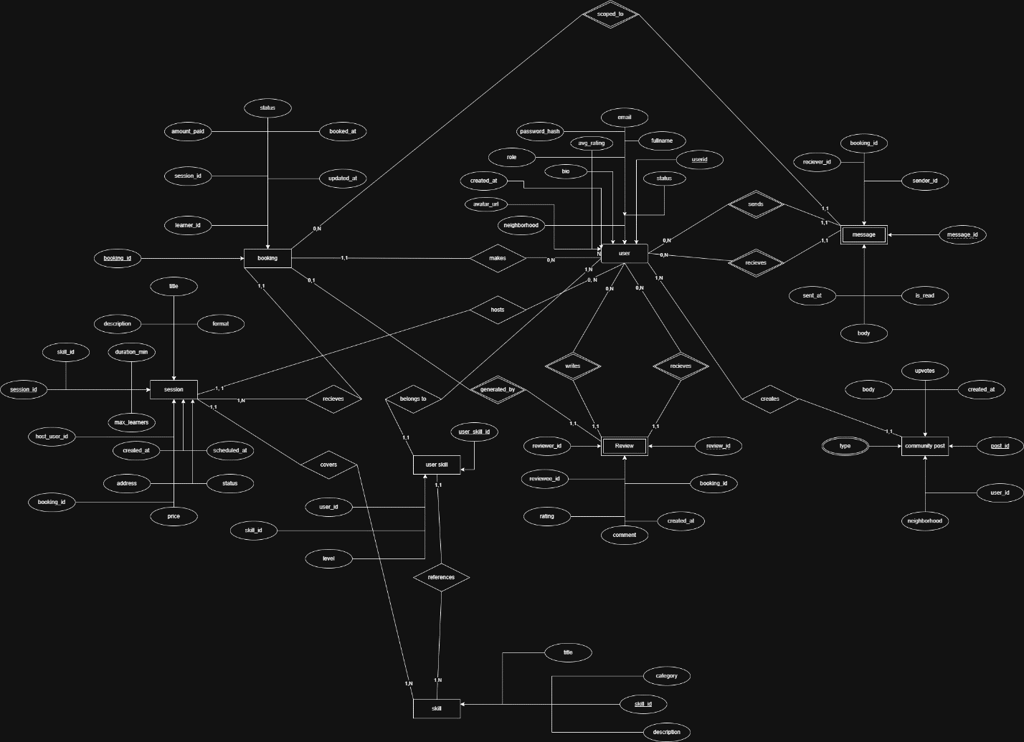
The database consists of 8 tables
5 strong entities:
USER, SKILL, SESSION, BOOKING, COMMUNITY_POST
2 weak entities: REVIEW, MESSAGE
1 junction entity: USER_SKILL resolving the M: N relationship between USER and SKILL.
USER stores all registered users across all three roles. The role field distinguishes between learner, teacher, and admin. avg_rating is a derived attribute recalculated after every new review.
SKILL is a pre-seeded catalog of teachable skills organized by category. It has no dependencies on any other table.
USER_SKILL is a junction entity resolving the M: N relationship between USER and SKILL. It records which skills a user has, their proficiency level, and whether they are offering to teach that skill.
SESSION represents a class or micro-session created by a teacher. It references both the host user and the skill being taught.
BOOKING records a learner reserving a spot in a session. It tracks the booking status through its full lifecycle from pending to complete.
REVIEW is a weak entity that cannot exist without a BOOKING. It is identified by its relationship with BOOKING and stores the rating and comment left after a completed session.
MESSAGE is a weak entity that cannot exist without a BOOKING. All messages are scoped to a confirmed booking between a learner and teacher.
COMMUNITY_POST stores neighborhood-scoped posts created by any user, categorized by type and supporting upvotes.

2. IMPLEMENTATION
2.1 DATABASE CREATION
- Database created in pgAdmin, DDL scripts are executed to create tables and populate them.
- Creates.sql , inserts.sql and views.sql are executed.
- Views created: open_sessions_view and completed_bookings_view
2.2 QUERIES
- Browse all open sessions with teacher and skill details
- View personal booking history with session and teacher info
- Search sessions by skill category and neighborhood
- View average rating and all reviews for a teacher
- View all sessions created by the teacher with booking count
- View all pending booking requests for teachers sessions
- View earning summary per session
- View all users with role and status
- Find teachers with highest number of completed sessions
- Transactions: complete a booking and trigger review eligibility, submit a review and update teacher rating automatically
3.

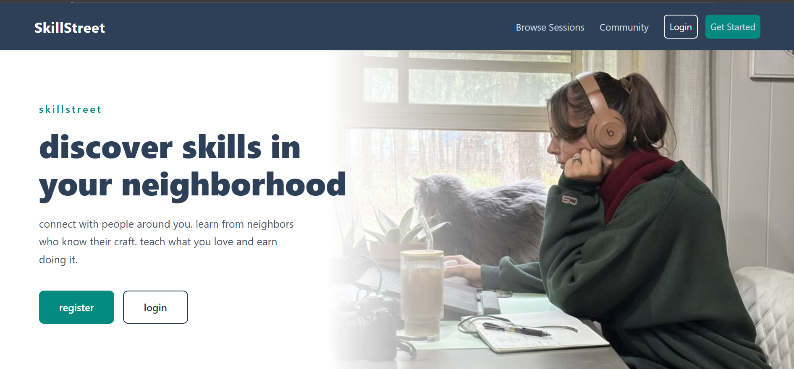


REGISTERATION PAGE
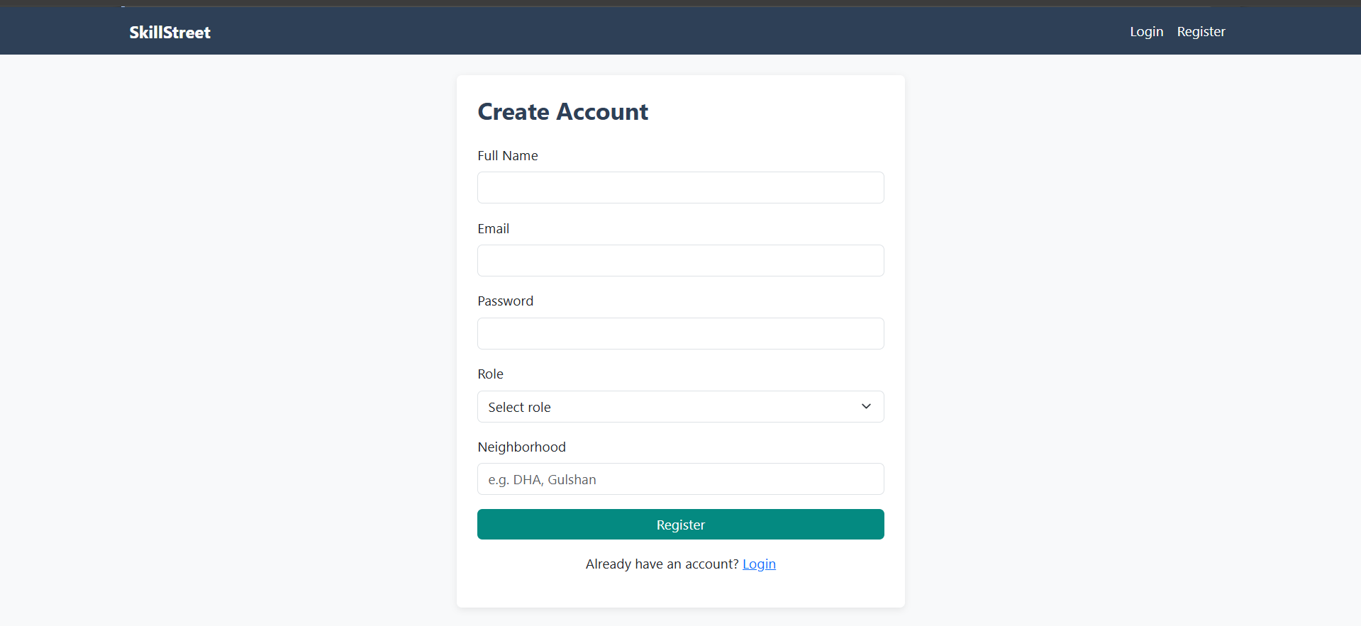
LOGIN PAGE
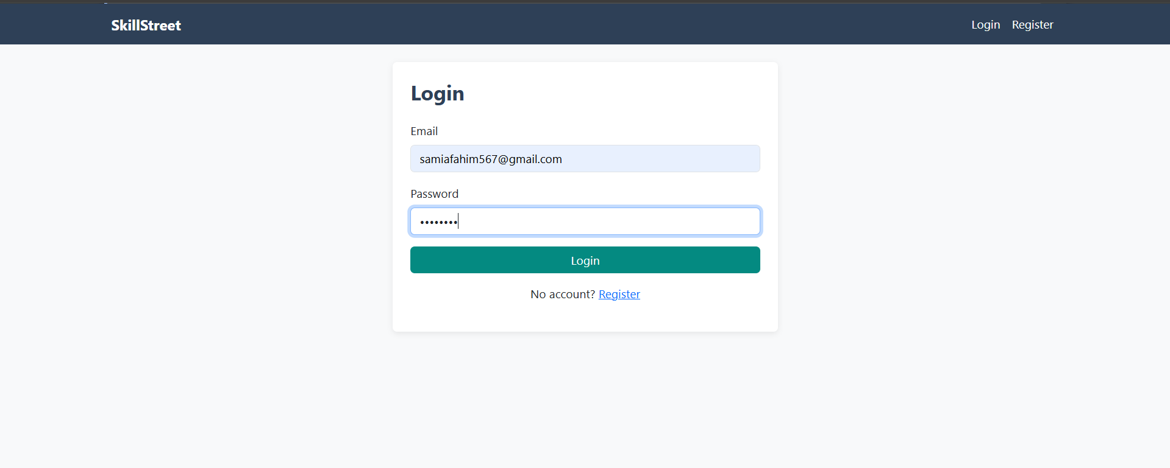
DASHBOARD (TEACHER)
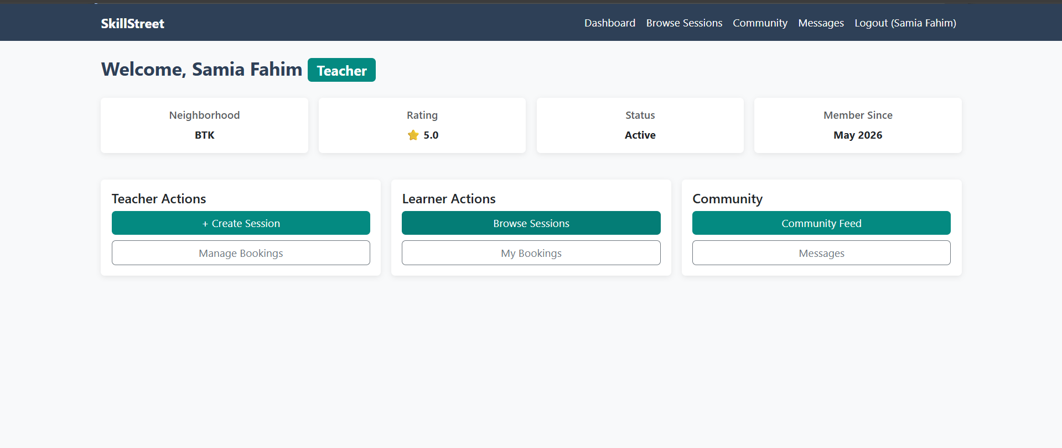

DASHBOARD (LEARNER)
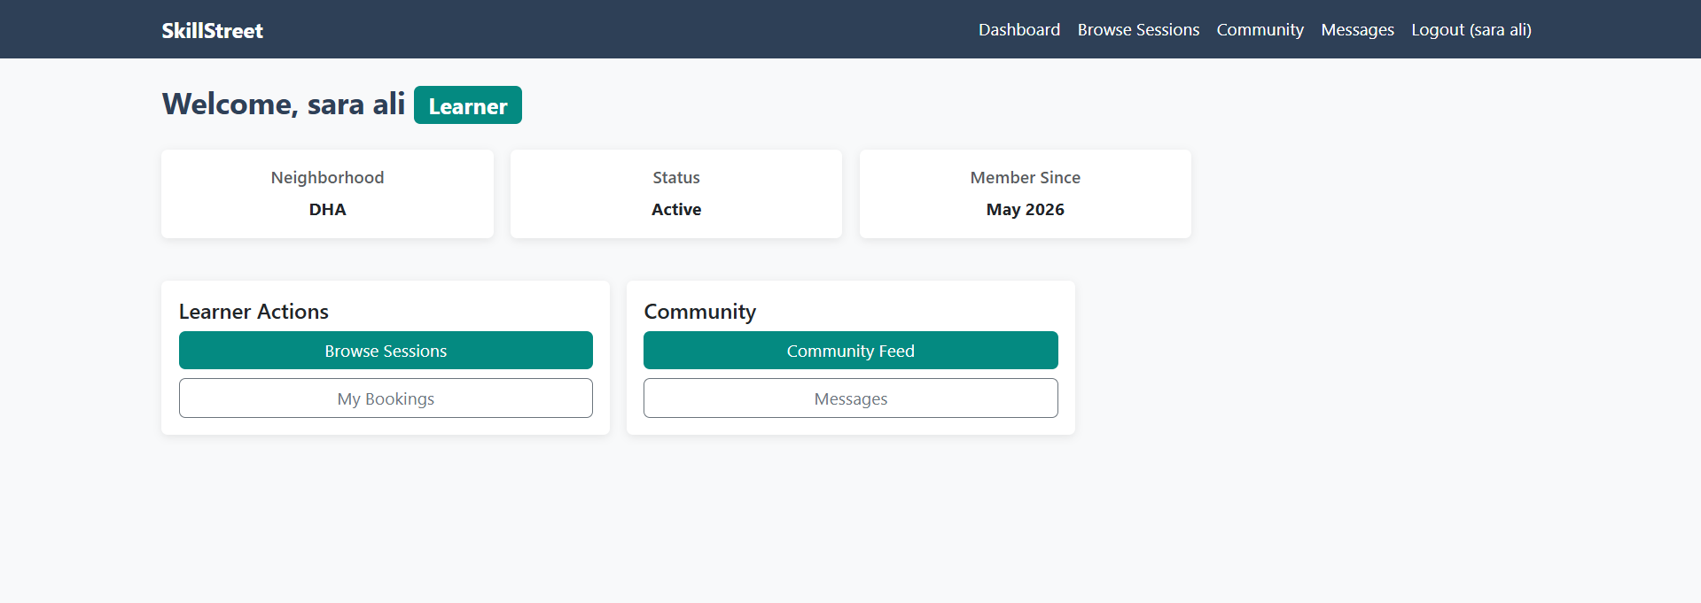
CREATING SESSION PAGE (TEACHER)
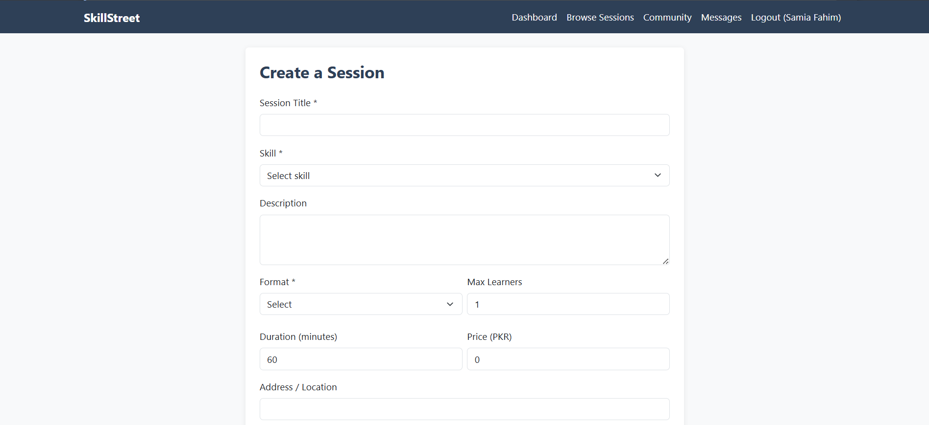
BOOKING CONFIRMATION PAGE (TEACHER)
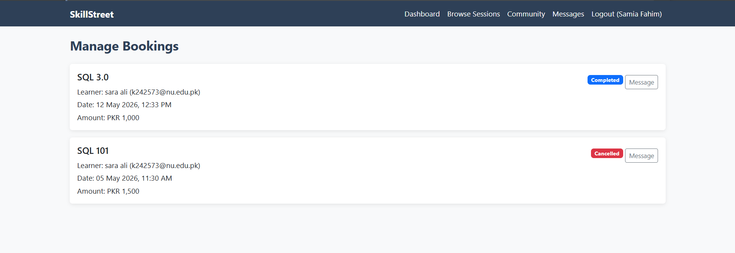

BOOKING SESSION PAGE
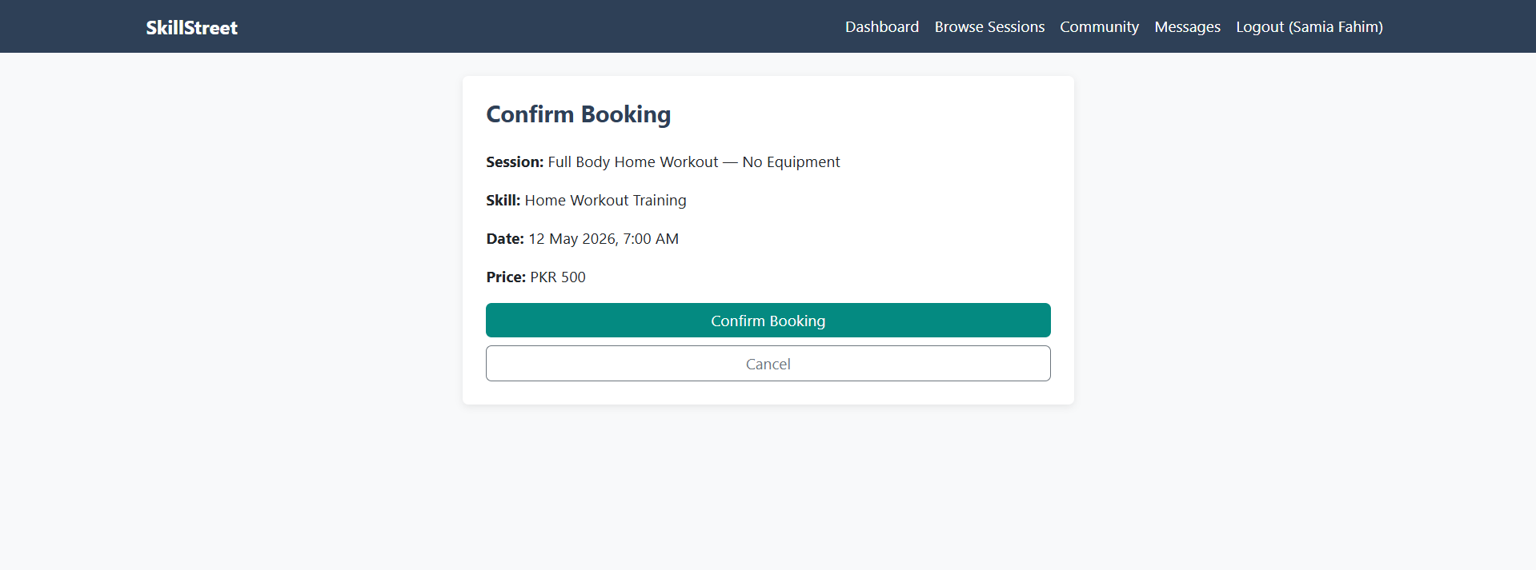

ALL BOOKINGS
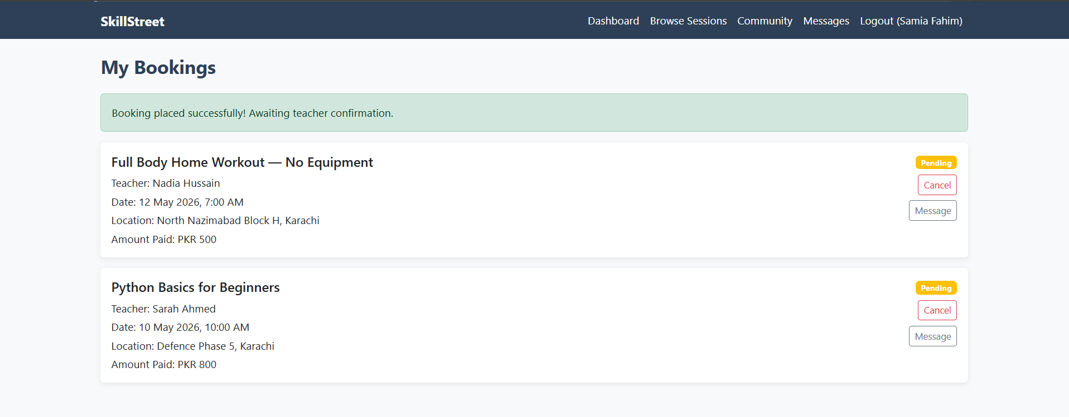

BROWSING SESSIONS PAGE
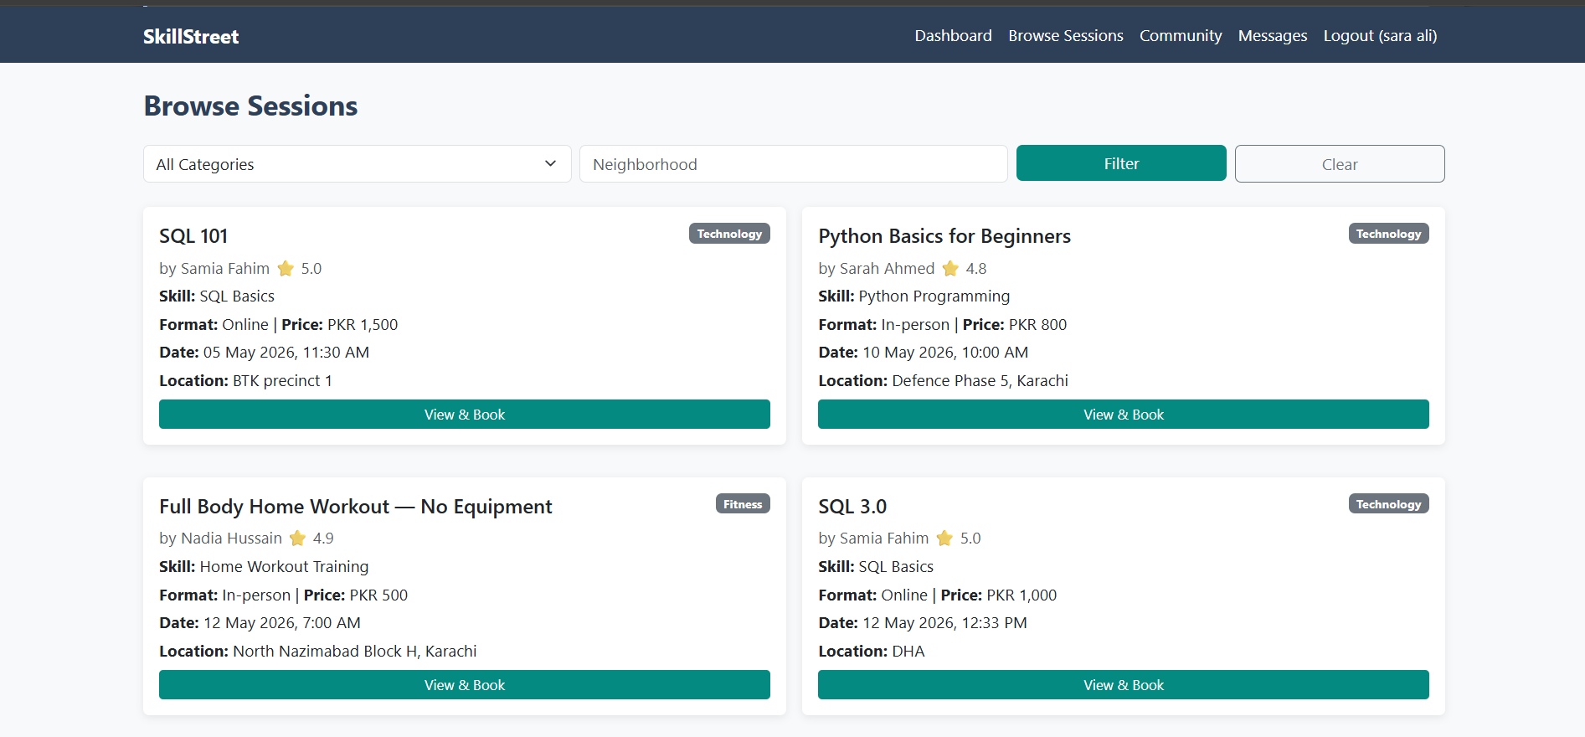

SESSION DETAILS
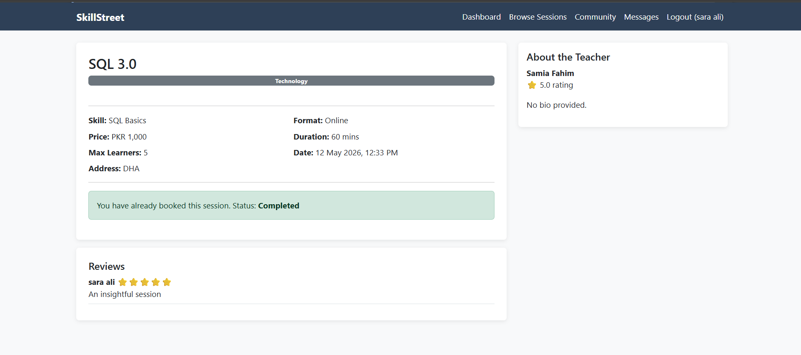

COMMUNITY FEED
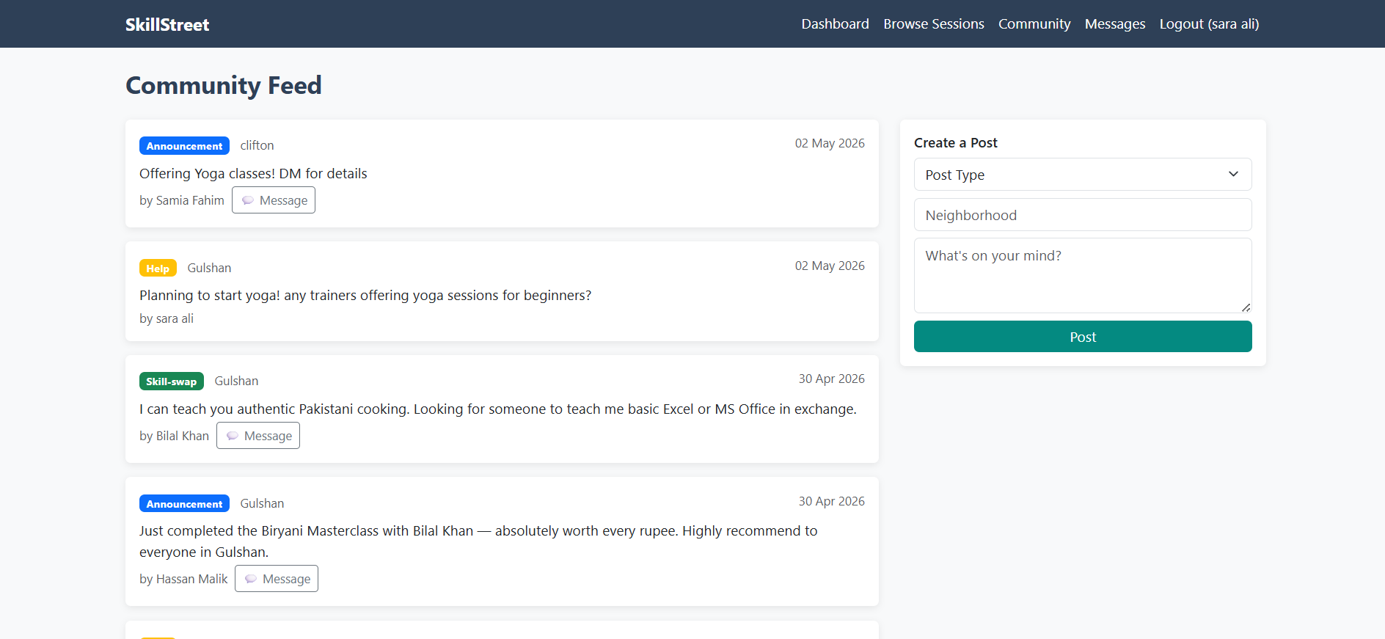

MESSAGES
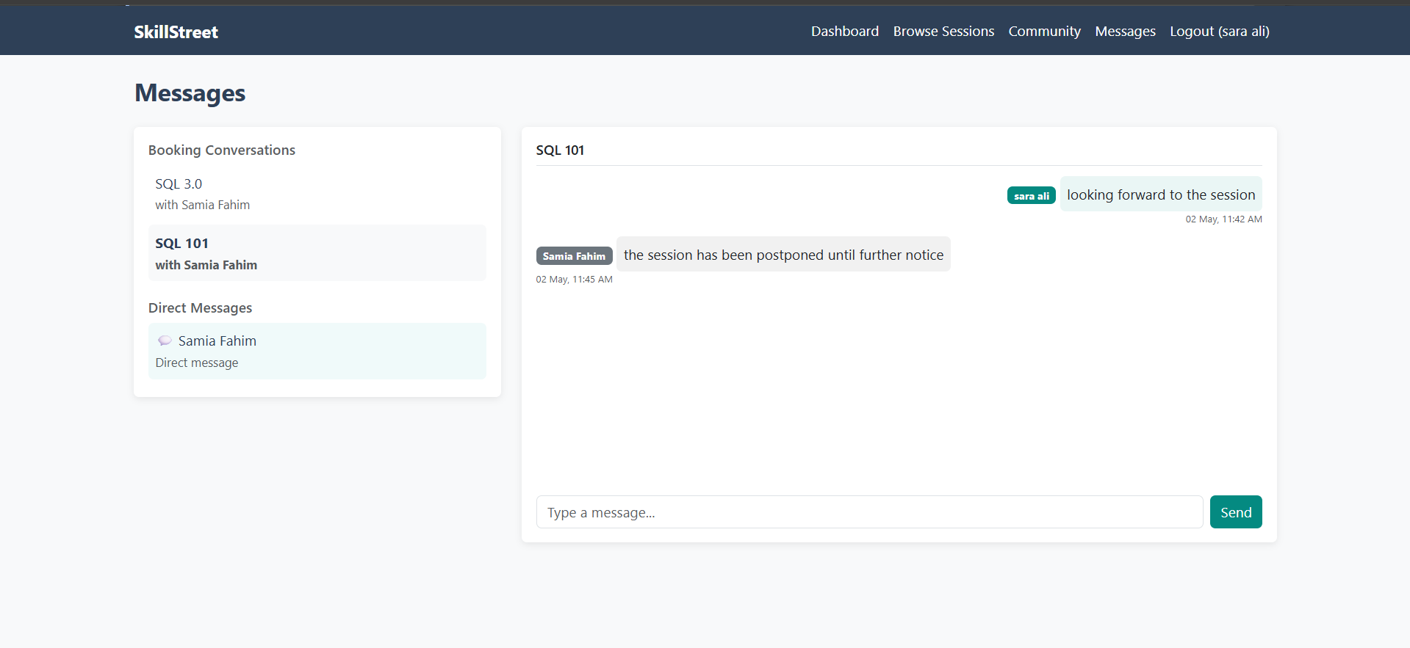

4. CONCLUSION

Skill Street successfully demonstrates the design and implementation of a fully normalized relational database for a real world web application. The project covers all phases from entity identification and ER diagram design through normalization to BCNF, SQL implementation with DDL and DML scripts, views, advanced queries with joins and aggregate functions, and transaction handling. The web application built on top of the PostgreSQL database using PHP and Bootstrap brings the schema to life with a functional interface for all user roles effectively

